3.1

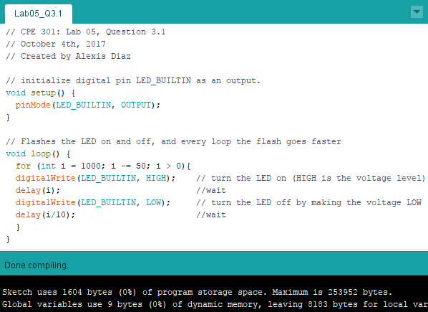3.2

Sketch uses 1604 bytes.

3.3

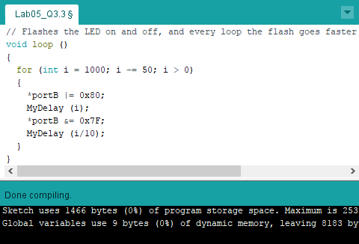34.

Sketch uses 1466 bytes.

4.1

